Chapter 2, Solution 35

20 Ω
i
-
+
i₁
I_{o}
70 Ω
30 Ω
5 Ω
b
a
i₂
200V
+
V_{o}
-
+
V₁
-

Combining the resistors that are in parallel,

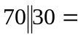 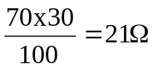 , 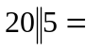 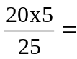4 Ω

i = 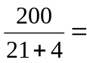8 A

v₁ = 21i = 168 V, v_{o} = 4i = 32 V
i₁ = 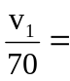 2.4 A, i₂ = 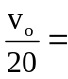 1.6 A

At node a, KCL must be satisfied

i₁ = i₂ + I_{o} 2.4 = 1.6 + I_{o} I_{o} = 0.8 A

Hence,
v_{o} = 32 V and I_{o} = 800 mA

